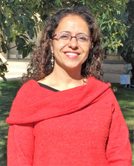
Dr. Tali Hadasa Blank
Senior Lecturer & Head of Innovation and Entrepreneurship,
Management of Service Organizations,
Hadassah Academic College, Israel.

Short Bio: Dr. Blank research and teaching interests include radical innovation, entrepreneurship, and organizational and team learning. In recent years Dr. Blank research focused on founding team factors and processes influence startups innovation and success.
During 2014-2016, Tali took postdoctoral associate position jointly at Cornell University and Harvard Business School. This is a joint research, mainly with Prof. Noam Wasserman, focusing on startups operated in university ecosystem. Before going abroad, during 2009-2014, Tali completed her PhD studies in Organizational Behavior, Faculty of Industrial Engineering and Management, Technion – Israel Institute of Technology. With her research advisor, Prof. Eitan Naveh, Tali study looked on: Radical Innovation in R&D Teams: The Effect of Learning Behavior, Promotion Focus, and Time Pressure. She obtained her Master degree with thesis at the Graduate School of Business Administration, Bar Ilan University. She worked with Prof. Avi Carmeli and study: The Effect of Founding Team Composition on the Success of Israeli New Ventures in the High-Technology Sector. Tali holds bachelor degree in mathematics and computer science and education from Haifa University

